|  |  |
| --- | --- |
| OUTLINE( | |
|  | Group Project Proposal |
|  |  |
| submission date:  10/25/2018 | **Carry Mark System** |
|  | **PREPARED BY**:  (1) [RAJA MUHAMMAD HANIF BIN RAJA RIZAL ISKANDAR] (2017197403)  (2) [MUHAMMAD AMIRUL HAZIM BIN ABD RAHMAN]  (2017153255)  (3) [AMEER FARHAN BIN FARIZAL] (2017142837)  (4) [NURUL NAJIHAH BINTI MOHD NASIR] (2017342811)  **CLASS**: CS2454[B]  **CSC443 – Web Programming**  Bachelor in Computer Science (Hons) Data Communication and Networking, UiTM Jasin  **FOR:**  MS NURUL FATIMAH BINTI ISHAK  Faculty of Computer & Mathematical Sciences |

Group Project Proposal

Table of content

|  |  |
| --- | --- |
| Topics | Page |
| 1. Table of Content 2. **The Project**     1. Project Background    2. Team Member Role    3. Problem Statements    4. Objectives    5. Scopes and limitations 3. **Suggested solution with ERD**    1. ERD    2. Flowchart | 1  2  3  4  4  5  6  6  7 |

**II) THE PROJECT**

1. **Project Background**

Peninsula College is a new college that offer few courses for students. As a new college, no system is available for the lecturers to store and automatically prints the carry marks for their students. This findings prompted to develop carry mark system for use by the lecturers to reduce their workload. Basically, the system requirements include the ability of the system to calculate total mark, average mark and able to print the carry mark of students based on their courses and classes. The system is design by using Entity Relationship Diagram(ERD) and PHPMyAdmin databases to store the classes, carry marks and student’s information. By having this kind of system, it will be easier to keep track of student’s progress.

1. **Team Member Role**

|  |  |  |
| --- | --- | --- |
| Information | Picture | Roles and Responsibilities |
| RAJA MUHAMMAD HANIF BIN RAJA RIZAL ISKANDAR | ../Desktop/Screen%20Shot%202018-10-17%20at%209.32.02%20PM.png | **PROJECT MANAGER**   * Discuss with the other members on how to complete the task. * Supervise the task given to ensure it is done on time. |
| MUHAMMAD AMIRUL HAZIM BIN ABD RAHMAN | ../Desktop/Screen%20Shot%202018-10-17%20at%209.32.46%20PM.png | **PROGRAMMER 1**   * Develop the programming system for database. |
| AMEER FARHAN BIN FARIZAL | ../Desktop/Screen%20Shot%202018-10-17%20at%209.32.32%20PM.png | **PROGRAMMER 2**   * Assist programmer 1 with the programming system and find the solution for problem occurs. |
| NURUL NAJIHAH BINTI MOHD NASIR | ../Desktop/Screen%20Shot%202018-10-17%20at%209.33.03%20PM.png | **DESIGNER**   * Develop the programming system for user interface. |

1. **Problem Statements**

Lecturer’s routine works is to process marks and results of student’s assessments. This poses a great burden to lecturers as they have to process the overall results. When processing these marks or results, they tend to make many errors unintentionally especially when they have to fill several different copies of forms for each set of results. These forms include lab assignments, quizzes and assignment, test and project.

Due to this problem, which is frequently faced by lecturers, this system proposed to design and build a system that can assist the lecturers in processing the marks and results of students.

1. **Objectives**

The objectives of this project are:

* To create a system that will record the student’s grade for quizzes, test and project.
* To reduce the workload of lecturers.
* To overcome error in the calculation of carry marks manually.
* To produce a standardized database for storing the marks of all students.
* To retrieve the data and information of student’s carry marks performance.
* To prepare and produce the processed results.
* To secure and maintain the integrity of data.

1. **Scopes and Limitations**

Scope of this project is for one course, one group with 20 students inside the database. This system is able to process student’s marks based on their course and classes.

The process will be handled by the proposed system include:

* Calculate the total carry marks of individual students.
* Calculate the average marks obtained by individual student.
* Printing the carry marks based on their course and class.

Limitations:

The limitation of developing a web-based carry mark system is the system can be only accessed by an authorized person. Moreover, the system is divided into two users and have difference type of functions that can be used.

**III) SUGGESTION SOLUTION WITH ERD**

1. **ERD**

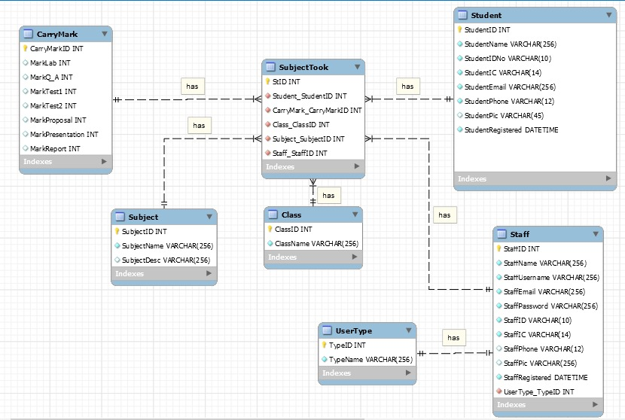

1. **Flowchart**

